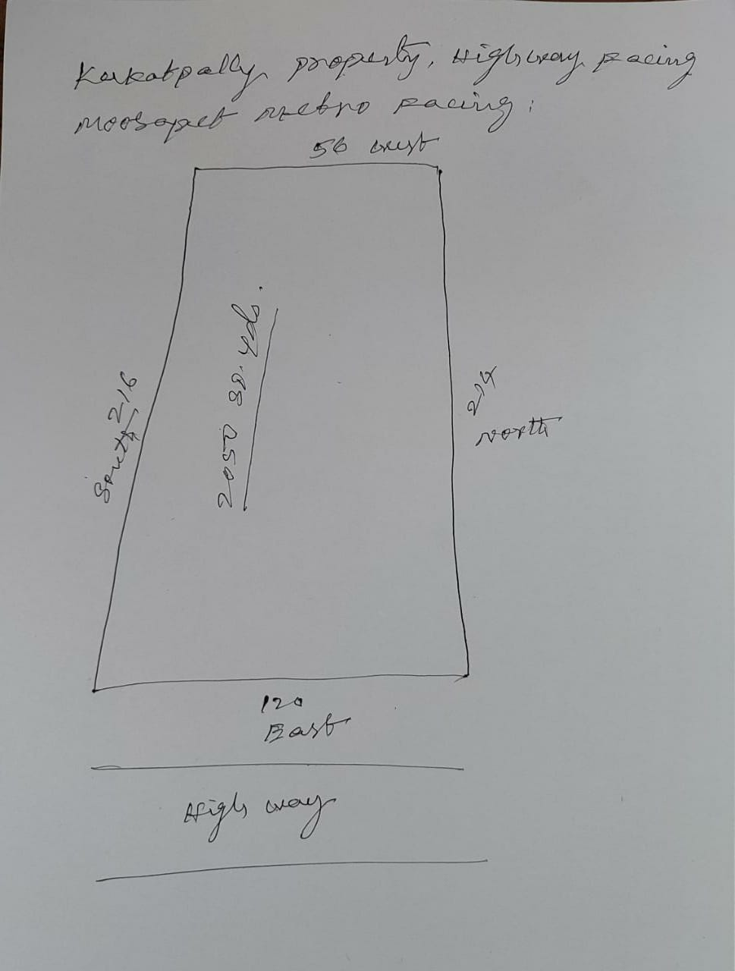

Owner : Koteshwar rao

Facing :

Dimensions :

Rate :